 SRM Institute of Science and Technology

Ramapuram campus

Department of Mathematics

18MAB101T-Calculus and linear algebra Branch:Common to All
Year/Sem: I/I
Unit 1 –MATRICES
Part-C

1. | (i)The characteristic equation using Cayley-Hamilton theorem for the matrix  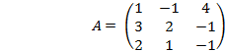 is | 4x3=12
1. | (a) A³ - 2A² - 5A+ 6I = 0 (b) A³ + 2A² +5A+ 6I = 0  (c) A³ - 5A² - 3A+ 2I = 0 (d) A³+A² - 3A - 5I = 0 | Ans  (a) | (CLO-1  Apply)
1. | (ii)The matrix A ² corresponding to the above problem is  (a)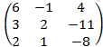 (b) 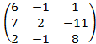  (c) 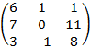 (d) 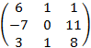 | Ans  (c) | (CLO-1  Apply)
1. | (iii)The characteristic polynomial for A⁴ using Cayley Hamilton theorem is  (a)2A³ + 5A² - 6A (b) A² - 3A - 5I (c) 2A³ - 5A² - 6A (d) A² + 3A+ 5I | Ans  (a) | (CLO-1  Apply)
1. | (iv) The value of A⁴ using Cayley Hamilton theorem is  (a) 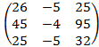 (b) 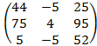  (c) 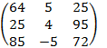 (d)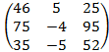 | Ans  (d) | (CLO-1  Apply)

.  2 | (i) The characteristic equation for the matrix 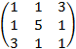 is | 4x3=12
.  2 | (a) (b)  (c) (d) | Ans  (a) | (CLO-1  Apply)
.  2 | (ii) Find the eigen values of the matrix 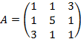  (a) -2, 3,6 (b) 2.-3,6 (c) 2,3,6 (d) 2,3,-6 | Ans  (a) | (CLO-1  Apply)
.  2 | (iii)The eigen vectors corresponding to the eigen values of the above matrix is  (a) (-1,0,1),(1,-1,1),(1,2,1) (b) (1,0,1),(1,-1,-1),(1,-2,1)  (c) (1,1,1),(2,-1,1),(1,2,-1) (d) (1,0,0),(1,1,1),(-1,2,-1) | Ans  (a) | (CLO-1  Apply)
.  2 | (iv)The diagonalised matrix P takes the form  D = 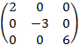 (b)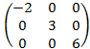 (c)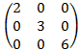 (d)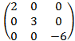 | Ans  (b) | (CLO-1  Apply)

3. | .(i) Reduce the quadratic form to a diagonal canonical form and hence find rank, index and nature. | 4x3=12
3. | - x²+ y² - 2z² (b) x²- y² - 2z² (c) x²+ y² + 2z² (d) -x²- y² -2z² | Ans  (a) | (CLO-1  Apply)
3. | (ii) Rank of the quadratic form is  - 2 (b) 1 (c) 3 (d) 0 | Ans  (c) | (CLO-1  Apply)
3. | (iii) Index and signature of the quadratic form is  - 2,1 (b)1,2 (c) 2,2 (d)1,1 | Ans  (a) | (CLO-1  Apply)
3. | (iv) Hence the nature of the quadratic form is  - Indefinite (b) positive definite  (c) negative definite (d) negative semidefinite | Ans  (a) | (CLO-1  Apply)

4. | (i) The characteristic equation for the matrix A 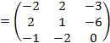 is | 4x3=12
4. | (i) (a) (b) (c) | Ans  (a) | (CLO-1  Apply)
4. | (ii) Find the eigen values of the above matrix  - -3,-3,5 (b)3,3,5 (c) 3,-3,5 (d) 3,3,-5 | Ans  (a) | (CLO-1  Apply)
4. | (iii)One of the eigen vector corresponding to λ = λ₁ is  - (3,0,1) (b) (1,-3,2) (c) (1,2,3) (d) (1,1,1) | Ans  (a) | (CLO-1  Apply)
4. | (iv) The eigen vector corresponding to distint eigen value λ is  (a) (1,2,-1) (b) (1,1,1) (c) (0,1,1) (d) (1,-1,3) | Ans  (a) | (CLO-1  Apply)

5. | The characteristic equation using Cayley-Hamilton theorem for the matrix  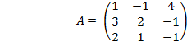 is | 4x3=12
5. | (i) (a) A³ - 2A² - 5A+ 6I = 0 (b) A³ + 2A² +5A+ 6I = 0  (c) A³ - 5A² - 3A+ 2I = 0 (d) A³+A² - 3A - 5I = 0 | Ans  (a) | (CLO-1  Apply)
5. | (ii) The matrix A ² corresponding to the above problem is  (a) (b)  (c) (d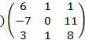 | Ans  (c) | (CLO-1  Apply)
5. | (iii) The matrix A ³ corresponding to the above problem is  (a)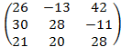 (b)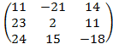  (c)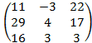 (d)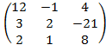 | Ans  (c) | (CLO-1  Apply)
5. | (iv) The corresponding matrix for A⁻¹ is  (a)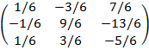 (b) 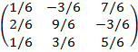  (c) 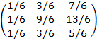 (d) 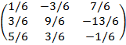 | Ans  (a) | (CLO-1  Apply)

6. | (i) Find the eigen values of the quadratic form is | 4x3=12
6. | (a) 0,3,15 (b) 1,2,3 (c) -2,3,6 (d) 1,1,4 | Ans  (a) | (CLO-1  Apply)
6. | (ii) The above quadratic form reduces to a diagonal canonical form  - 0y₁²+ 3y₂² +15y₃² (b)y₁²+ 2y₂² +3y₃²  (c)-2y₁²+ 3y₂² + 6y₃² (d)y₁²+ y₂² +4y₃² | Ans  (a) | (CLO-1  Apply)
6. | (iii)Rank of the quadratic form is  - 2 (b) 1 (c) 3 (d) 0 | Ans  (a) | (CLO-1  Apply)
6. | (iv) Index and signature of the quadratic form is  - 2,1 (b)1,2 (c) 2,2 (d)1,1 | Ans  (c) | (CLO-1  Apply)

